Student Management

Searching for Course

Version <1.0>

Revision History

|  |  |  |  |
| --- | --- | --- | --- |
| **Date** | **Version** | **Description** | **Author** |
| <dd/mmm/yy> | <x.x> | <details> | Đào Anh Thành |
|  |  |  |  |
|  |  |  |  |
|  |  |  |  |

Table of Contents

1. Searching for course 3

1.1 Brief Description 3

2. Flow of Events 3

2.1 Basic Flow 3

2.2 Alternative Flows 3

2.2.1 < First Alternative Flow > 3

2.2.2 < Second Alternative Flow > 3

3. Special Requirements 3

3.1 < First Special Requirement > 3

4. Preconditions 3

4.1 < Precondition One > 3

5. Postconditions 3

5.1 < Postcondition One > 3

6. Extension Points 3

6.1 <Name of Extension Point> 3

Searching for Course

# Searching for course

## Brief Description

This use case defines the step of searching for a specific computer. User can easily search for specific computers by providing the key information.

# Flow of Events

## Basic Flow

User chooses one of the two following ways to search for course: searching by course’s attributes or searching by entering keywords.

## Searching by course’s attribute

On the computer shop’s home page, user selects the necessary attributes of the wanted course in the selectors. Eventually, user clicks the search button nearby, the system will filter and then display the list of computers having the chosen attributes.



## Searching by keywords

On the computer shop’s home page, user enters the keywords of the desired computers in the search bar at the upper right corner. Eventually, user clicks the search button next to, the system will search and then display the list of computers having the given keywords.

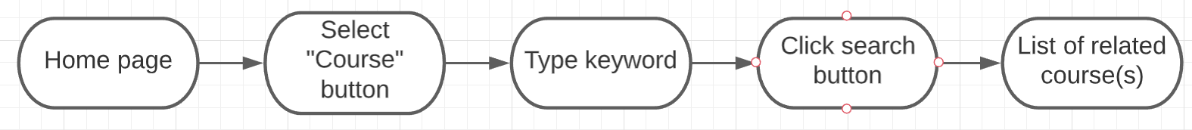

# Special Requirements

Keyword-related course (e.g: ID, name,…) are sorted in order of best matches

# Preconditions

## A computer must be classified and tagged with its genres.

# Postconditions

No postcondition points.

# Extension Points

No extension points.